WHEN: | Tuesday, September 20, 2022  12:00pm-1:30pm
WHERE: | Let’s Meet Virtually with Zoom!!– Please register here on the YVC-SHRM StarChapter website.
WHO: | Al Falcon M.S. LCPC, LAC

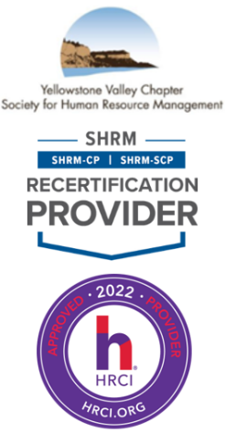
Employee Burnout, Well-Being, and the Importance of Self-Care
Al Falcon, LAC, LCPC, will be doing a presentation on Employee Burnout and Self-Care. He will discuss understanding employee burnout, causes and the signs and symptoms of it.

HR professionals will be able to identify the multiple dimensions of well-being and self-care. Additionally, attendees will be able to understand the importance of self-care and how to create an environment promoting such.

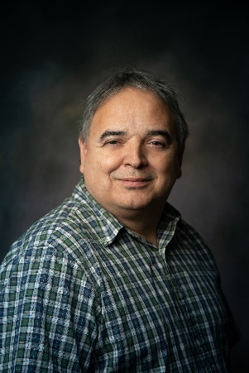
Mr. Al Falcon is the Center Director for the Billings Urban Indian Health and Wellness Center (BUIHWC, pronounced BUICK). BUIHWC is a community medical/mental health center that has a strong Native American cultural component within its mission but does not just focus on the Urban Native American population. Mr. Falcon oversees the Clinic operations and the behavioral health department, which includes mental health therapy and substance use services. Mr. Falcon’s team combines substance use disorder (SUD), Mental health therapy (MH) and medical services to holistically serve clients, focused on betterment, growth, recovery, and healing.

Mr. Falcon has worked in the MH, SUD field as a primary licensed addiction counselor (LAC) and licensed clinical professional counselor (LCPC) with an emphasis on working with individuals with co-occurring disorders. He has worked both as a clinician and in administrative leadership for both community Mental and Behavioral Health Centers over the years. Mr. Falcon has been a member of the Montana Substance Use Task Force. He has participated in various Q&A panels over the years to further educate audiences about SUDs and MH and how the conditions intersect.

Mr. Falcon continues to mentor people in recovery that have reached out as part of their recovery and although his focus as a professional is primarily in administrative leadership, he continues to work with individuals as a therapist or LAC when his time allows. Mr. Falcon takes this role very seriously, with gratitude and joy as he teaches and sculpts future clinicians in the science and art of helping people grow, manage and heal from SUDs and mental health related issues.

Please RSVP online by 5:00 p.m. on Friday, May 6, 2022. Registration Link: https://yvcshrm.starchapter.com/meetinginfo.php
If you have any questions, please contact YVC SHRM President, Amy Schneider, aschneider@sandersonstewart.com, 406.869.3324. Thank you and enjoy the program.

