WHEN: | Thursday, June 16th from 3:30—4:30
WHERE: | Teams--Please register here on the YVC-SHRM StarChapter website to receive the link for the program.  THIS EVENT IS FREE!
WHO: | Patrick Barkey-University of MT Director of Bureau of Business and Economic Research
NEWS & UPDATES: | YVC SHRM Summer Social TBA  https://yvcshrm.starchapter.com
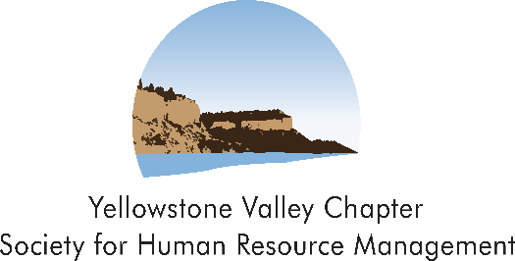
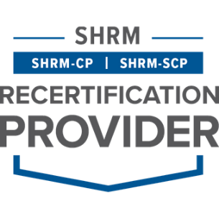


Montana Economic Outlook

Pat will be discussing the following related to Montana:
- Current economic climate
- Economic projections
- Workforce projections
- Population projections
- Where growth in MT is projected to occur
- Anything else he feels we need to know


Patrick Barkey has served as Director of the Bureau of Business and Economic Research since 2008. He has been involved with economic forecasting and policy research for more than 30 years, in both the private and public sectors.
Before coming to Montana he served as Director of the Bureau of Business Research at Ball State University in Indiana for fourteen years. His recent research has been on the economic impact of energy development, the property tax treatment of the telecommunications industry and the economic impact of trade with Canada. He holds a B.A. and a Ph.D. in economics from the University of Michigan.


Please RSVP online by 2:00 p.m. on Thursday, June 16, 2022. Registration Link: https://yvcshrm.starchapter.com/meetinginfo.php
If you have any questions, please contact YVC SHRM President, Amy Schneider, aschneider@sandersonstewart.com 406.855.9663
Thank you and enjoy the program.

