WHEN | Tuesday, June 8, 2021  12:00 p.m. – 1:30 p.m.
WHERE | Zoom – Please register here on the YVC-SHRM StarChapter website to receive the link for the program
WHO | Britney & Sammy Higgs, Founders/Directors  HER Campaign
COST | $15 – YVC-SHRM Members/Members of other Chapters  $25 – Non-Members  Free – Students/Pre-paid Members
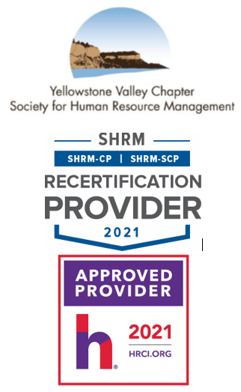

Relationship Management - HER Campaign
The mission at HER Campaign is to help HER (survivors of sexual exploitation and human trafficking) heal, grow, and find purpose. HER Campaign accomplishes this by providing residential programs for survivors.
HER Campaign was founded as a 501(c)(3) Non-Profit Organization in 2016. In 2017, the founders opened HER Refuge, the organization’s first long term residential program in Billings and have been walking the journey of healing with women stepping out of sex trafficking since that time.
Services that residents received through the HER Refuge were meant to help them lead a life of independence. Services included living in a loving family environment, basic daily living skills, resources to creative therapies (equine, art, etc.), medical, group and individual therapy, job skills training, and employment opportunities.
In 2021, the focus at HER Campaign has been on developing relationships with shelter programs nationwide, learning best practices and standards of care to develop credibility and building more residential programs throughout Montana that will fulfill a much-needed gap in survivor care throughout the state. This year, HER Campaign is expanding programs to provide survivors service throughout the continuum of care including a 24/7 rescue hotline, emergency shelter, long term residential program focusing on restoration, and transitional housing for survivors with children.
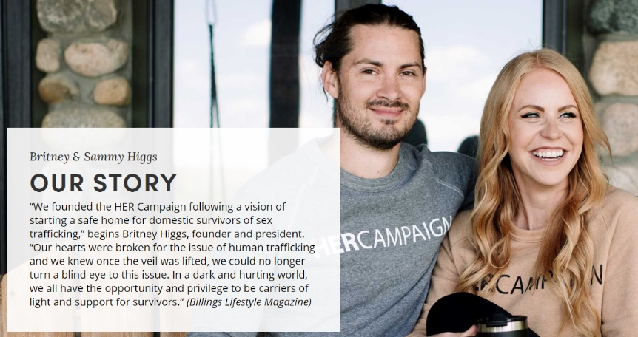
At the heart of the HER Campaign is a desire to cultivate long lasting relationships and collaboration with agencies, law enforcement, other non-profits, and elected officials throughout Montana and beyond to create best standards of care for survivors, ultimately helping survivors step into independence and reintegration back into society.
Human trafficking is a non-partisan issue. There is a lot right now in our society that we don’t agree on. Human trafficking is one thing that we see the majority of people on any side seeing as a huge issue and something that needs to be addressed from all aspects including awareness, prevention, rescue, and recovery. It will take us all focusing on our lanes, building each other up with mutual respect, and working together to see that happen successfully throughout the state of Montana and beyond. HER Campaign is here to help make that a reality.

Please RSVP online by 11:59 a.m. on Tuesday, June 8, 2021.
If you have any questions, please contact YVC SHRM President, Amy Schneider, aschneider@sandersonstewart.com, 406.869.3324.

Thank you and enjoy the program.

