WHEN: | Tuesday, April 13, 2021  12:00 p.m. – 1:30 p.m.
WHERE: | Zoom – Please register here on the YVC-SHRM StarChapter website to receive the link for the program
WHO: | David Horning | Water Cooler Comedy
COST: | $15 – YVC-SHRM Members/Members of other Chapters  $25 – Non-Members  Free – Students/Pre-paid Members
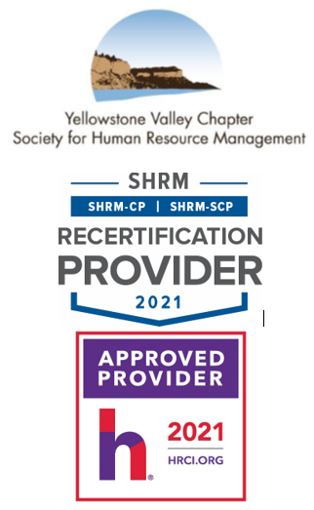
Lead With Laughs: Use Humor to Put the “Human” in HR
We could all use a laugh right now. Did you know that a little laughter can actually help adapt to change and give your team the skills to face emerging workplace trends of the 21st century head on? Because of the pandemic, managers are being forced to pivot on the fly, leading to an increase in workload, stress, and pessimism. What if you had a tool at your disposal that could relieve your stress while boosting your team’s engagement levels, resilience, and productivity?
We’ve been conditioned to believe that "work isn't the time or place to laugh,” but this outdated adage has a demotivating and destructive effect on our ability to deal with uncertainty, innovate, and solve problems.

“Lead With Laughs” will leave you energized and ready to act on new ideas for transforming your workplace into a safe space for creativity, collaboration, and fun that will engage and inspire you and your team. We will cover:
- 4 reasons why addressing employee engagement in new ways is urgent in a post-pandemic world for recruiting, engaging, and retaining millennials and gen-z talent.
- 5 hallmarks that differentiate demotivating management and inspiring leadership.
- The definition of humor, its most common myth, and why it’s necessary for inspiring creativity and engagement.
- A simple life hack (or laugh hack in this case) for quickly adapting to unexpected adversity.
- guidelines for incorporating humor into your workplace culture.

David Horning, Founder | Water Cooler Comedy
Combining 8 years of comedy with 6 years of speaking, David Horning is on a mission to prepare teams for the shifting workplace of the 21st century. He has entertained and inspired audiences to use humor as a tool to adapt to change, relieve stress, engage teams, spark creative collaboration, and improve productivity with programs that turn traditional leadership on its head.
In addition to speaking, David continues to perform stand-up, has been featured in The New York Comedy Festival, hosts a podcast called “You Can’t Laugh At That” featuring guests ranging from comedians, to humor researchers, to CEOs in order to explore the ins & outs of humor theory, stand-up comedy, joke writing, & humor in the workplace. He has appeared as a guest expert on leadership & HR podcasts such as HR After Dark, The Chad And Cheese Podcast, The Indigo Podcast, & others. He is currently working on his first book.

Please RSVP online by 5:00 p.m. on Monday, April 12, 2021.
If you have any questions, please contact YVC SHRM President, Amy Schneider, aschneider@sandersonstewart.com, 406.869.3324.

Thank you and enjoy the program.

