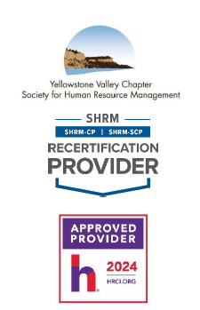 | WHEN: Tuesday, March 11th, 2025  12:00 p.m. – 1:30 p.m.
WHERE: Sysco Montana, 1509 Monad Rd, Billings, MT 59101

Come to the blue building off Daniel St. Park in the parking lot closest to the traffic light at the corner of Monad & Daniel.

Register on the yvcshrm.starchapter.com website
 | COST: $20.00
Facing Resistance From Above: A Case Study From Maryland
Presentation Summary:
As an HR professional, you know how to protect your company and its employees. But do you know how
to protect yourself? Join Scott Oswald, an accomplished employment lawyer, for this webinar discussing
potential job actions and retaliation against HR professionals – all through the lens of a fellow SHRM
member who went to trial against his former employer.
Learning Objectives:
- Learn how to internally handle conflict between what is legally and morally right and what upper management asks them to do
- Learn how to stand up to upper management in the event that HR is being pressured to engage in unlawful acts or otherwise violate company policy
- Be able to identify retaliation and possible steps to fight against it
- Know possible consequences if they choose to obey upper management and ignore company policy or the law.
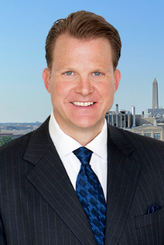
Scott Oswald, managing principal at The Employment Law Group, is an accomplished trial lawyer who has brought 40+ trials to verdict and recovered more than $300 million for his clients, in cases ranging from wrongful termination to employer fraud. Mr. Oswald litigates employment lawsuits nationwide, with a focus on whistleblower matters. He has spoken up for workers before federal agencies and on Capitol Hill and has broken new ground in whistleblower law. Mr. Oswald is also a member of SHRM.
Please RSVP online by 5:00 p.m. on Monday, March 10th, 2025.
If you have any questions, please contact YVC SHRM President, Gerri Glover @gerriglover@spherion.com

