WHEN: | Tuesday, March 9, 2021
WHERE: | Zoom – Please register here on the YVC-SHRM StarChapter website to receive the link for the program
WHO: | Matt Mosser | Chief Human Resources Officer  Gallup
COST: | $15 – YVC-SHRM Members/Members of other Chapters  $25 – Non-Members  Free – Students/Pre-paid Members

The Art and Science of Effective Leadership
Unprecedented is probably the word that was used most in 2020. Twenty-twenty will forever be remembered as the year that changed the way businesses operated including forcing owners/operators to come up with new and innovative ideas to continue to thrive during unprecedented times.
As HR professionals, we were not immune to these unprecedented times and were left scrambling trying to support our organizations in ways that we may have scoffed at in the past. One thing is for sure, the workplace changed more than anyone would have imagined in 2020. Managing at-home workers, burnout and mental health all came to the forefront last year. When added to the fact that only 1 in 3 US employees were engaged at work prior to 2020, it is clear how badly the US needs great leaders and managers to lead their organizations forward in 2021 and beyond.
In this session you will hear from Gallup CHRO, Matt Mosser, about today’s hottest workplace topics, Gallup’s research findings, and stories about what Gallup’s best-in-class clients are doing to lead their teams to a new future.
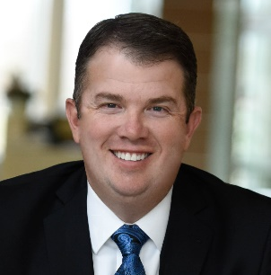
Matt Mosser, Chief Human Resources Officer | Gallup
Future-oriented, strategic CHRO focused on talent growth & people development. With over 25 years of experience Matt leads the global talent strategy for Gallup. Matt also leads Gallup’s Organizational Performance Consulting group, the team responsible for consulting with clients around change management, talent acquisition and leadership development. In addition, Matt advises Fortune 500 clients to build human capital strategies focused on talent-based recruiting, employment brand, management development & culture change. As a key member of Gallup’s Executive Committee, Matt shapes the future of Gallup for all their clients and employees.
Top 5 CliftonStrengths: Individualization | Maximizer | Arranger | Focus | Significance

Please RSVP online by 5:00 p.m. on Monday, March 8, 2021.
If you have any questions, please contact YVC SHRM President, Amy Schneider, aschneider@sandersonstewart.com, 406.869.3324.

Thank you and enjoy the program.

