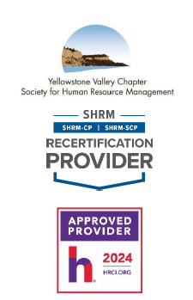 | WHEN: Tuesday, February 18th, 2025  9:00 a.m. – 1:00 p.m.
WHERE: Sysco Montana, 1509 Monad Rd, Billings, MT 59101

Come to the blue building off Daniel St. Park in the parking lot closest to the traffic light at the corner of Monad & Daniel.

Register on the yvcshrm.starchapter.com website
 | COST: $100.00
Workplace Communication Workshop: Master Tough Conversations & Lead with
Confidence
Struggling with workplace communication challenges? Learn how to navigate difficult conversations, conflict resolution, and leadership communication with confidence. This interactive workshop will equip you with the skills to:
Handle tough conversations and workplace conflicts effectively
Communicate change in leadership and manage organizational shifts
Strengthen supervisor-employee relationships for a more engaged team
Build confidence in open and productive discussions
Increase your influence, leadership, and communication impact in the
workplace
Great leaders communicate effectively—are you ready to level up?

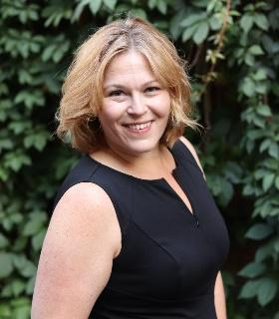
A professional speaker, international speaking coach, and four-time international best-selling author, Shelby is a recognized expert in corporate communications. She works with prominent CEOs, professional athletes, and influencers in executive coaching and consulting to help companies amplify their influence in the marketplace with a comprehensive brand presence. In all of her endeavors, she helps clients develop a comprehensive brand strategy for thought leadership. Shelby is also CEO of Business Dynamics and CEO of Rogue Publishing Partners, where she helps visionaries develop an infrastructure for their business and influence. Her particular method helps ingenious entrepreneurs position their idea in the marketplace. Her bestselling book, I See Your Genius: Transform Your Idea into Income, is a valuable reference and guide for entrepreneurs.
Please RSVP online by 5:00 p.m. on Monday, February 17th, 2025.
If you have any questions, please contact YVC SHRM President, Gerri Glover @gerriglover@spherion.com

