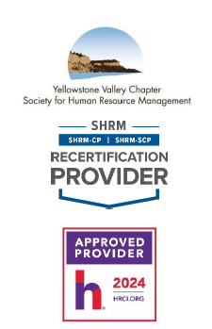 | WHEN: Tuesday January 21, 2025  12:00 p.m. – 1:30 p.m.
WHERE: Sysco Montana,
1509 Monad Rd
Billings, MT 59101

Come to the blue building off Daniel St. Park in the parking lot closest to the traffic light at the corner of Monad & Daniel.

Register on the yvcshrm.starchapter.com website
 | COST: $20.00
 | This will be a virtual in person meeting at Sysco Montana. If you cannot make it to the in person virtual but would like to attend, you are more than welcome to register and watch from your location, select the ticket, virtual no lunch for $15.00.
Workforce Recovery Friendly

Shannan Sproull has a long history working in substance use prevention and for three years facilitated a community coalition addressing substance use gaps. Shannan is the Program Director for Recovery Friendly Montana, which oversees the Recovery Friendly Workplace Initiative. The RFW initiative was launched almost two years ago in Missoula, and now has engaged businesses in Ronan, Butte, Helena, and Great Falls.

The Recovery Friendly Workplace initiative promotes individual wellness by creating work environments that further mental and physical well-being of employees—proactively preventing substance misuse and supporting recovery from substance use disorders in the workplace community: www.RecoveryFriendlyMT.org


Please RSVP online by 5:00 p.m. on Monday, January 20, 2025.
If you have any questions, please contact YVC SHRM President.
Gerri Glover | gerriglover@spherion.com | 406.655-9200

Thank you and enjoy the program.

