WHEN: | Tuesday, January 11, 2022  12:00 – 1:30 p.m.
WHERE: | Zoom  RSVP on the StarChapter website for the link
WHO: | Yowlanda Henry, CHRO  Alternatives, Inc.
COST: | $15 – YVC-SHRM Members/Members of other Chapters  $25 – Non-Members  Free – Students
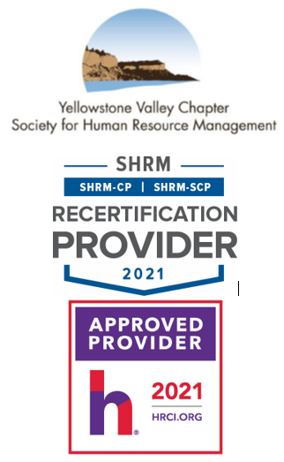

Inclusion: Making the Numbers Count!
Diversity and inclusion are two interconnected concepts, but they are far from interchangeable. Diversity is about the numbers, representation or make-up of an entity. Inclusion is about making the numbers count.

This presentation discusses the importance of inclusion and what it truly means to ensure people feel a sense of belonging and support. Organizations may have many different genders, races, nationalities, and sexual orientations and identities present but only certain groups are valued or carry any influence, they may be diverse, but they are not inclusive. During this presentation we will discuss inclusion and the value that it adds to your organization. Attendees will learn inclusion is not about loss, but about gaining experience and knowledge that may not exist in one’s sphere of comfort.

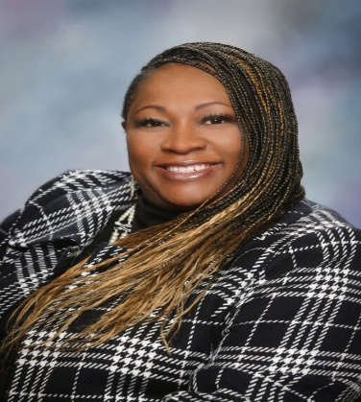
Yolawnda Henry is the Chief Human Resources Officer for Alternatives Inc. (a pre-release facility) That promotes public safety and challenges offenders to become responsible, productive citizens, she has over 25 years’ experience specializing in recruitment, strategic management, diversity, equity and inclusion, organizational development, collective bargaining, and employee relations. She has lived and worked in Florida, Georgia, Arizona, and Nevada. She is a board member of Yellowstone Valley Chapter of Society for Human Resource Management, and she serves on the Chamber of Commerce’s Diversity Steering Advisory board. She is a certified DiSC trainer and Arbinger facilitator. Yolawnda is also an architect for the William B. Henry Experience and will be one of many speakers at the 1st Annual Diversity Equity Inclusion and Implementation Leadership Conference April 21, 2022 at the DoubleTree Inn, Billings MT.

Please RSVP online by 11:59 a.m. on Tuesday, January 11, 2022.
If you have any questions, please contact YVC SHRM President, Amy Schneider, aschneider@sandersonstewart.com, 406.869.3324.

Thank you and enjoy the program.

